**DIGITAL NURTURE 4.0 DEEP SKILLING JAVA FSE-WEEK1**

**NAME: SIVITHA GUNASEKARAN**

**SUPERSET ID: 6413354**

**WEEK 1: DESIGN PATTERNS AND PRINCIPLES**

**Exercise 9: Implementing the Command Pattern**

**Scenario:** You are developing a home automation system where commands can be issued to turn devices on or off. Use the Command Pattern to achieve this.

**Steps:**

1. **Create a New Java Project:**
   * Create a new Java project named **CommandPatternExample**.
2. **Define Command Interface:**
   * Create an interface Command with a method **execute()**.
3. **Implement Concrete Commands:**
   * Create classes **LightOnCommand**, **LightOffCommand** that implement Command.
4. **Implement Invoker Class:**
   * Create a class **RemoteControl** that holds a reference to a Command and a method to execute the command.
5. **Implement Receiver Class:**
   * Create a class **Light** with methods to turn on and off.
6. **Test the Command Implementation:**
   * Create a test class to demonstrate issuing commands using the **RemoteControl**.

**CODE SAMPLES:**

interface Command {

void execute();

}

class Light {

public void turnOn() {

System.out.println("Light is ON");

}

public void turnOff() {

System.out.println("Light is OFF");

}

}

class LightOnCommand implements Command {

private Light light;

public LightOnCommand(Light light) {

this.light = light;

}

public void execute() {

light.turnOn();

}

}

class LightOffCommand implements Command {

private Light light;

public LightOffCommand(Light light) {

this.light = light;

}

public void execute() {

light.turnOff();

}

}

class RemoteControl {

private Command command;

public void setCommand(Command command) {

this.command = command;

}

public void pressButton() {

command.execute();

}

}

public class CommandPatternExample {

public static void main(String[] args) {

Light light = new Light();

Command on = new LightOnCommand(light);

Command off = new LightOffCommand(light);

RemoteControl remote = new RemoteControl();

remote.setCommand(on);

remote.pressButton();

remote.setCommand(off);

remote.pressButton();

}

}

**MY SCREENSHOT PROOFS:**

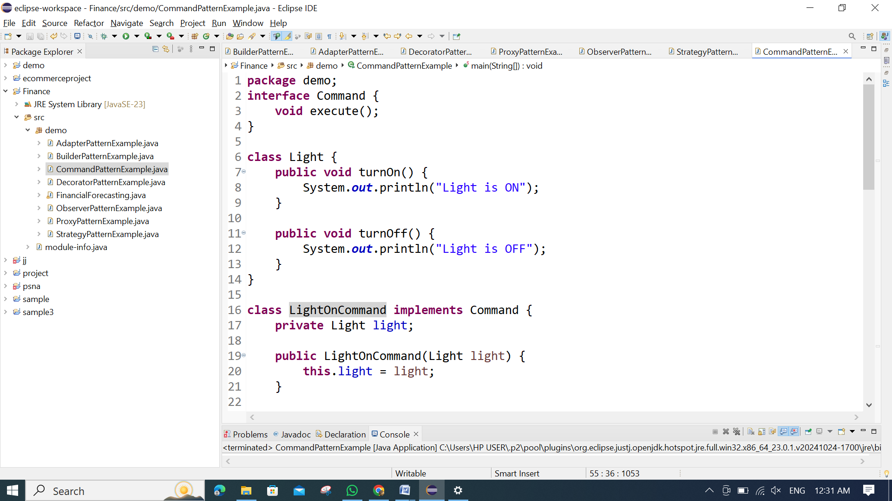

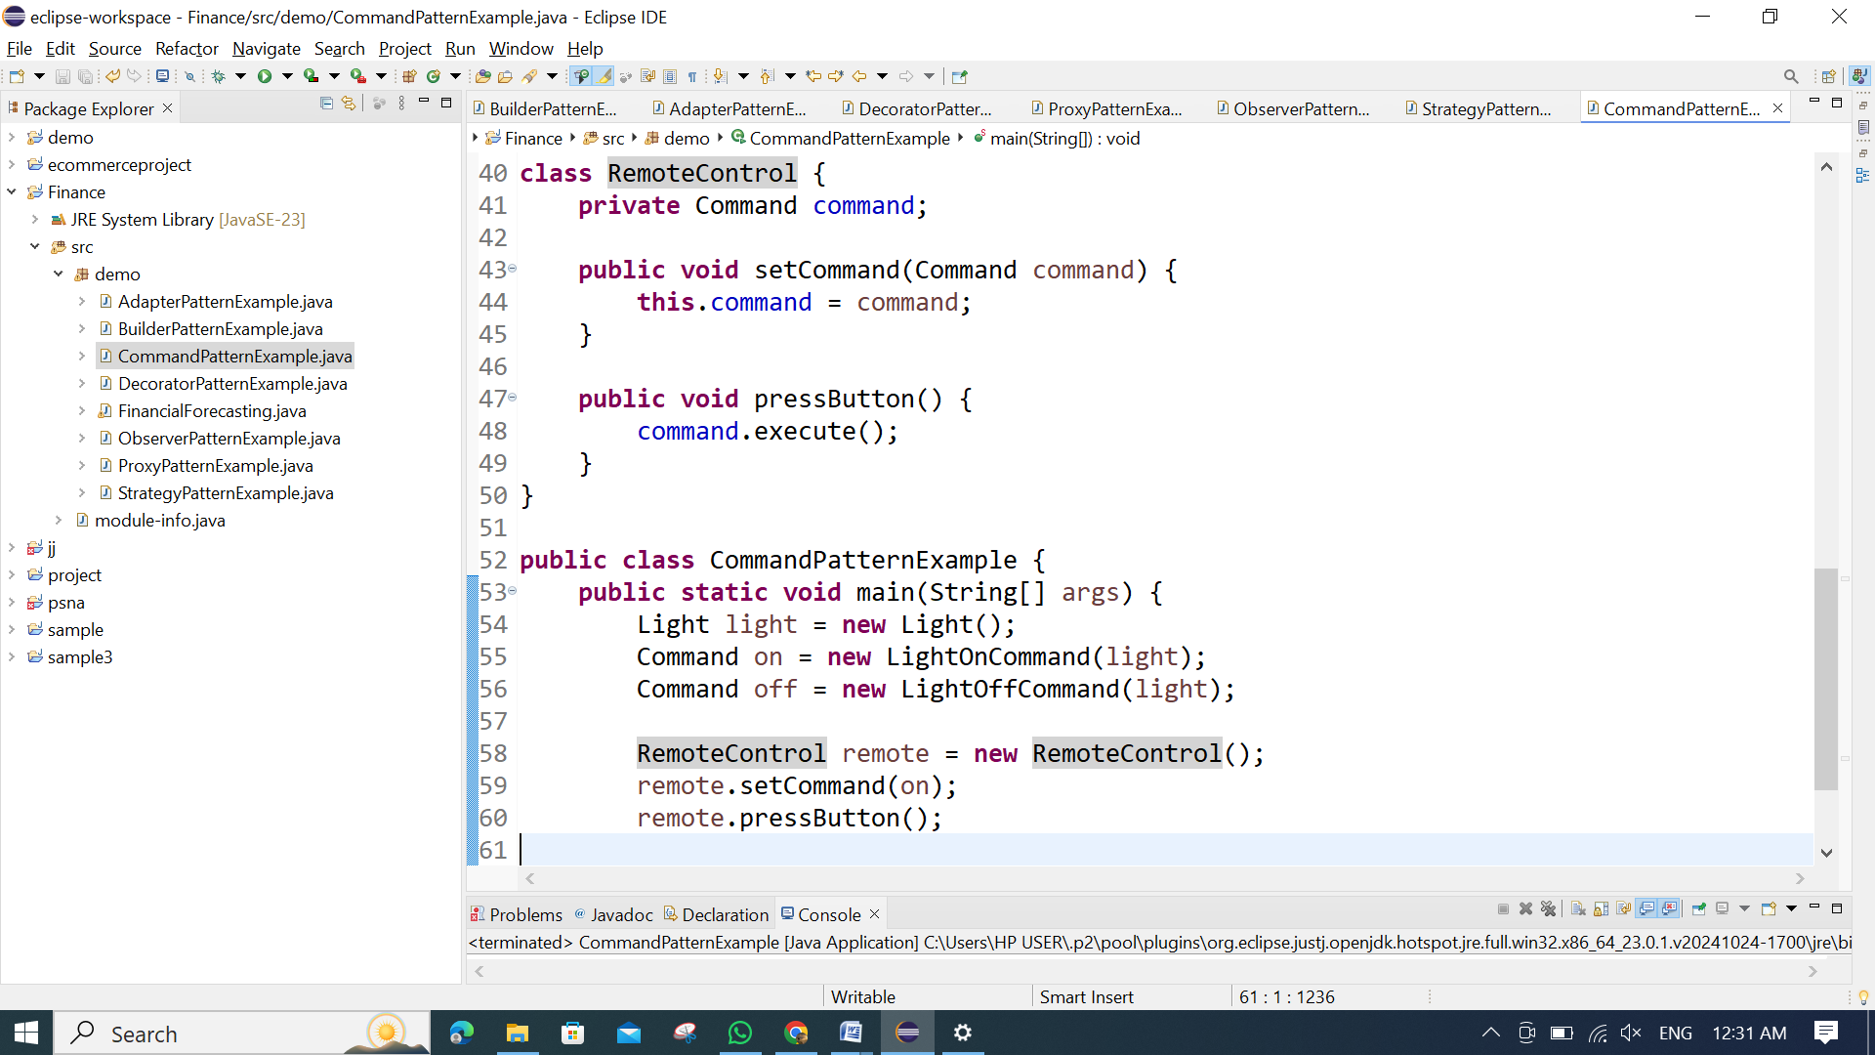

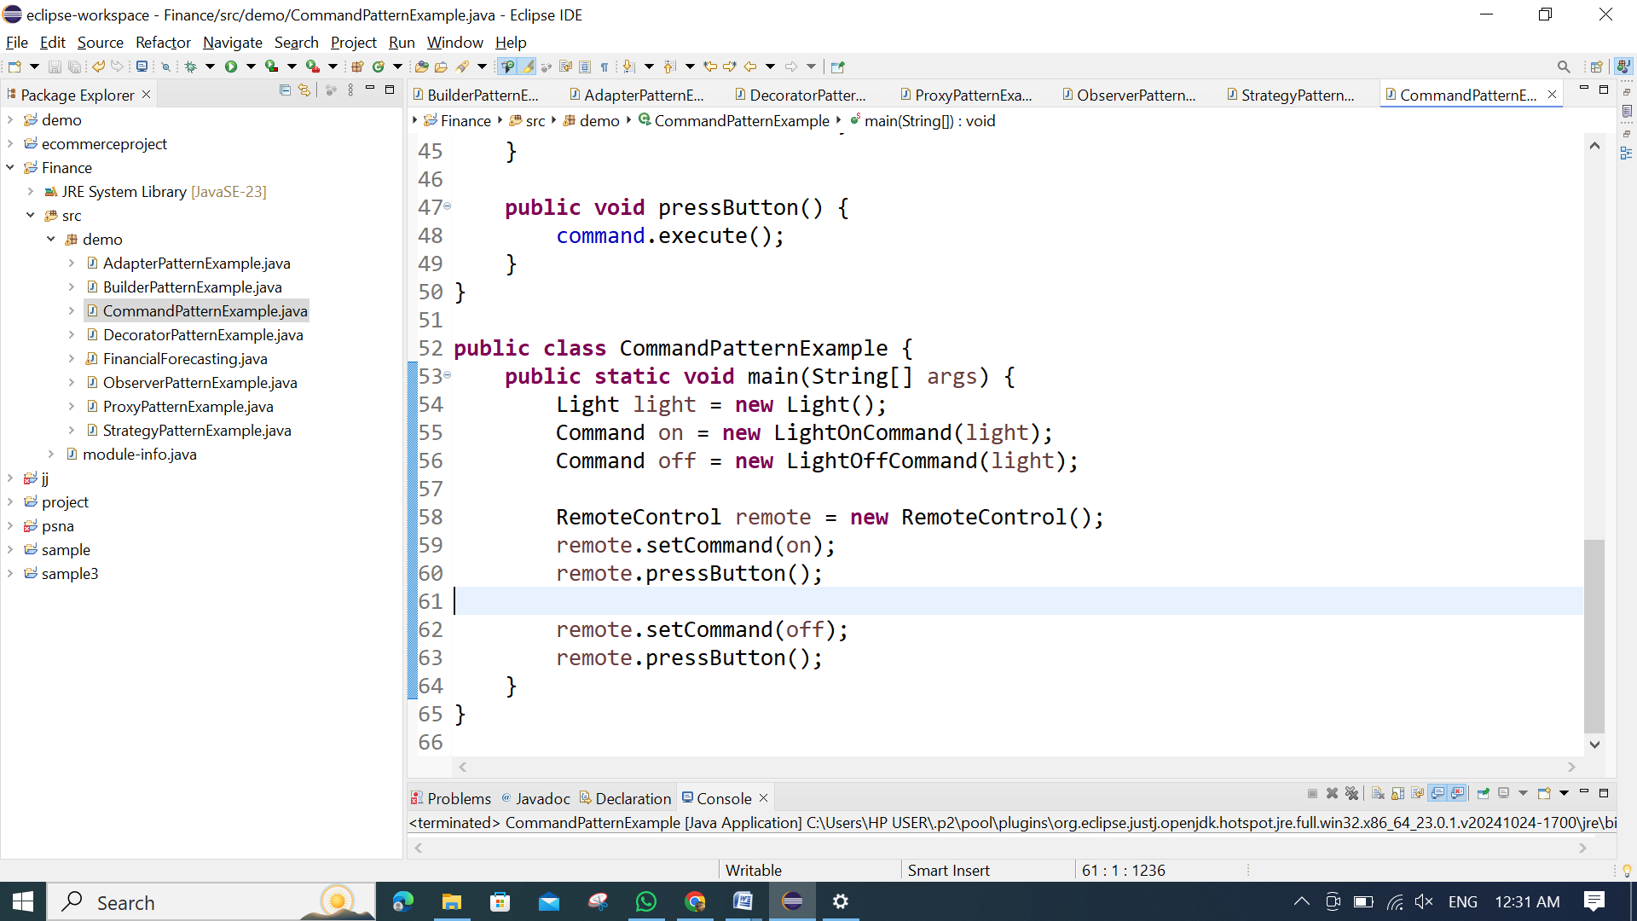

**OUTPUT:**

